**Practical 6**

1. Trace the programs below. Understand the output produced on the screen.
2. Testing the *cmath* library functions



1. Demonstrating string assignment and concatenation using string class



1. Demonstrating string comparison capabilities using string class



1. Using C-string for string
2. Write a C++ program that reads a string of text from the user and convert the string to all uppercase.
3. Declare your string using string class
4. Declare your string using C-string (assume the size of string is 50)
5. Write a C++ program that continuously prompts the user to enter a character to verify whether it is a vowel (a, e, i, o, u), until the user press ‘9’ to stop.
6. Write a program that gets a character from the user and tells whether it is a letter. If the character entered is a letter, your program also has to tell its numerical location in the alphabet (for example, ‘e’ and ‘E’ would both be 5). If it is not a character, its numerical location will be -1. Note: You are not allowed to use **isalpha**() function but you can use **toupper**() or **tolower**() function.
7. This program is a simple guessing game. The computer is to generate a **random number between 1 and 5**. The user is given up to **3 tries** to guess the exact number. After each guess, you are to check if the guessed number is equal to the random number. If it is equal, no more guesses should be made. If the user has not guessed the number after 3 tries, display the number with an appropriate message and terminate the game.

|  |  |
| --- | --- |
| I am thinking of a number between 1 and 5  Can you guess what is it? **5**  Not this. Please try again: **2**  Not this. Please try again: **3**  Congratulations! You did it. | **Example of Successful**  **Dialog** |

|  |  |
| --- | --- |
| I am thinking of a number between 1 and 5  Can you guess what is it? **2**  Not this. Please try again: **4**  Not this. Please try again: **3**  Sorry :( The number was 1.  Better luck next time. | **Example of Unsuccessful**  **Dialog** |

1. Write a C++ program that receives a positive floating-point number from the user. Your program will round the number to two decimal places. For example, if 123.456789 are entered, 123.460000 would be printed on the screen as the output.
2. Write a C++ program that will find and count the number of a similar character input by user from the string below:

                    "I am a good student. My Lecturer loves me very much. Thank you"

              Example output on the screen:





**Extra exercise**

1. Write a program to display a table of values for angle **α** (in degree), **α** (in radian) and side **C** of the triangle shown. The length of side C can be calculated using the law of cosines as shown below. Use for loopto calculate C as angle α varies from 0 to 90 degrees in 15 degree increments. Use math library function to assist you. Define PI as 3.14159.

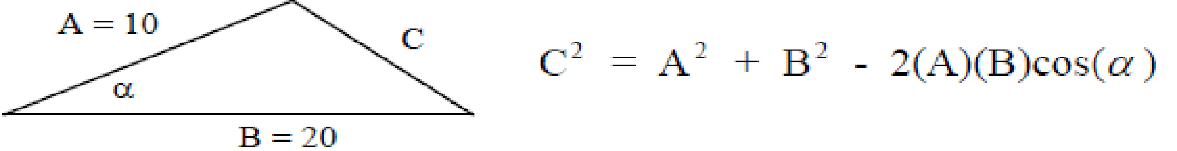

Sample output is shown below:



1. Write a C++ program that asks the user to enter a line of text and then displays the text. From the text, counts and displays the occurrence of an uppercase character, lowercase character, space, digit and other characters. The user's input data is shown in **boldface**.



1. Write a C++ program that asks the user to enter a sentence and your program will display the sentence backward.

Example:



1. Write a C++ program that calculates the squares and cubes of the integers from 1 to 10 using **pow()** function and uses **setw()** to print the following neatly formatted table of values:



1. Write a C++ program that prints the following table using the **sqrt** function in the **cmath** library.

Number SquareRoot

0 0.0000

2 1.4142

… …

18 4.2426

20 4.4721